Bahria University,

Karachi Campus



LAB EXPERIMENT NO.

___02___

LIST OF TASKS

|  |  |
| --- | --- |
| TASK NO | OBJECTIVE |
| **01** | Create 4 Components Each Component contains at least 5 Classes. |
| **02** | Add Attributes and Operations in Classes for Forward Engineering |
| **03** | Add more operations and Attributes via Coding in JAVA language for Alll Classes and Apply Reverse Engineering for changing Class Diagram |
|  |  |

Submitted On:

17-03-2023

(Date: DD/MM/YY)

**Task No. 1:** Create 4 Components Each Component contains at least 5 Classes

**Solution:**

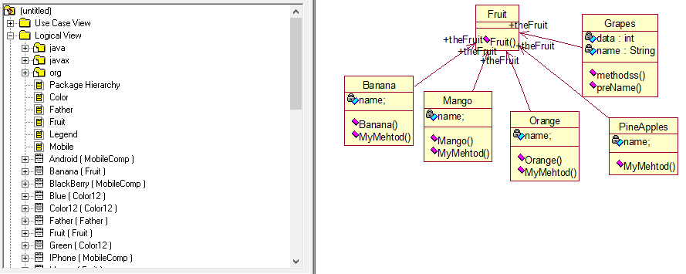

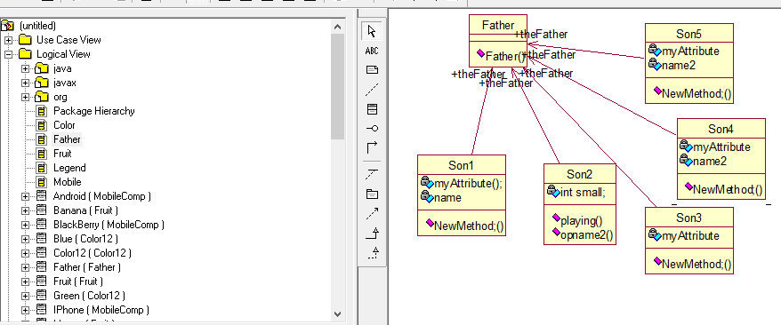

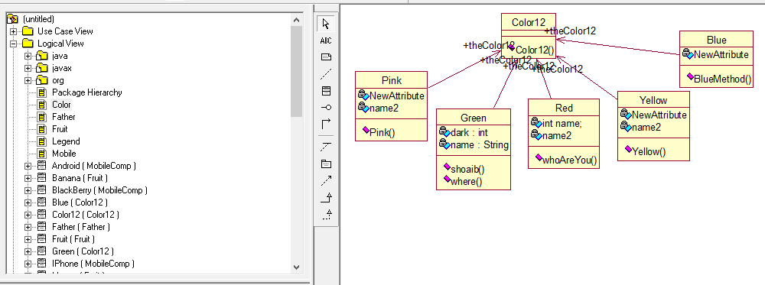

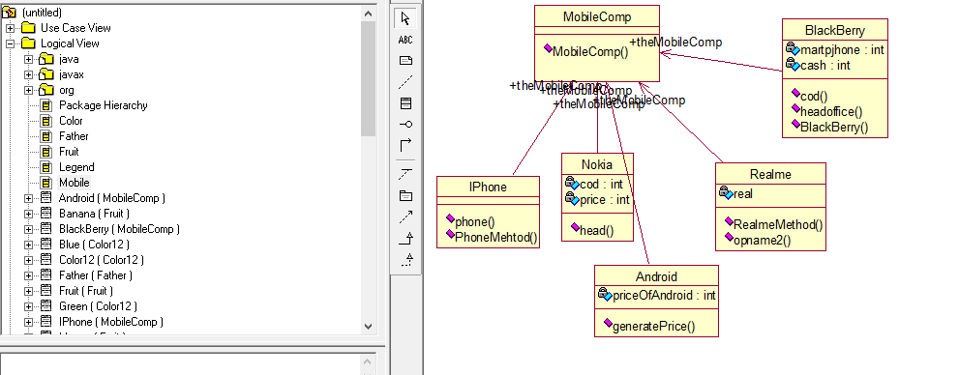

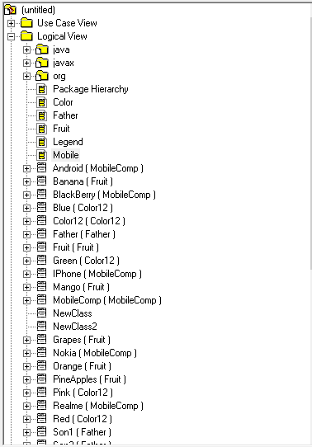

**Task No. 2:** Add Attributes and Operations in Classes for Forward Engineering

**Solution:**

**Component 1:**

//Source file: C:\\muty\\MobileComp.java

public class MobileComp {

public MobileComp() { }}

private class Android {

public MobileComp theMobileComp;}

private class Nokia {

public MobileComp theMobileComp;

private int cod;

private int price;

public void head() {}}

private class Realme {

public MobileComp theMobileComp;}

private class BlackBerry {

private int martpjhone;

private int cash;

public MobileComp theMobileComp;

public BlackBerry() {

private int martpjhone;

private int cash;}

public void cod() {

private int martpjhone;

private int cash;}

public void headoffice() {

private int martpjhone;

private int cash;}}

private class IPhone {

public MobileComp theMobileComp;}

**Component 2:**

//Source file: C:\\muty\\Father.java

public class Father {

public Father() {}}

private class Son5 {

public Father theFather;

private int age;

private String name;

public void play();}

private class Son1 {

public Father theFather;

private int martpjhone;

private int cash;}

private class Son2 {

public Father theFather;}

private class Son3 {

public Father theFather;

private int martpjhone;

private int cash;}

private class Son4 {

public Father theFather;

private int martpjhone;

private int cash;}

**Component 3:**

//Source file: C:\\muty\\Color12.java

public class Color12 {

public Color12() {}}

private class Green {

public Color12 theColor12;

private int dark;

private String name;

public void shoaib();

public void where();}

private class Blue {

public Color12 theColor12;}

private class Pink {

public Color12 theColor12;}

private class Red {

public Color12 theColor12;}

private class Yellow {

public Color12 theColor12;

public Yellow() {}}

**Component 4:**

//Source file: C:\\muty\\Fruit.java

private class Banana {

public Fruit theFruit;

public Banana() {}}

public class Fruit {

public Fruit() {}}

private class Mango {

public Fruit theFruit;

public Mango() { }}

private class Grapes {

public Fruit theFruit;

private int data;

private String name;

public void methodss();

public void preName();}

private class Orange {

public Fruit theFruit;

public Orange() {}}

private class PineApples {

public Fruit theFruit;}

**Task No. 3:** Add more operations and Attributes via Coding in JAVA language for Alll Classes and Apply Reverse Engineering for changing Class Diagram

**Solution:**

